Name: - **Index # 1** **Score** ____ **rtn Code**___________-________

Please check your responses with <http://qrproblems.org/ice1> or scan the QR code. You will need to put in your index number to check your responses. When you are finished checking, click the “get rtn Code” button at the bottom of the sheet - **Write the score and the rtn Code in the space provided above**. Documenting your work is important as an engineer – please return this sheet along with your work. A 30-point deduction will be assessed if I cannot easily follow your work. If you run into problems, please check the hints on the website then see if you can get the answers to the base-case problem. If you still are having problems, contact me.

Oddly enough, it was a women’s hockey game that led to demise of the vice president of academic affairs and the replacement of the school mascot. The lady thunder were up 8 to 0 at the start of the third period. Thor, the previous university mascot, and the then VPAA for Trine University, went into the room containing the ice rink’s refrigeration system to “shoot dice”. While trying to retrieve one of the dice, Thor’s hammer broke a valve on the rink’s ammonia refrigeration system. The VPAA quickly replaced the valve with a copper valve that was lying around so that ammonia leakage was minimal, and the illicit game could continue. According to investigators, it was the failure of this replacement valve that eventually led to the large ammonia release two months later that you have all heard about.

The response to the incident was immediate, first the mascot was replaced by one that does not carry a hammer. It is of course not possible to find a vice president that does not shoot dice, but one was found that knew the corrosive properties of ammonia. The last item is to investigate the replacement of ammonia as the refrigerant in the Thunder Ice Arena – that’s where you come in. A simplified process flow diagram for the ice rink’s refrigeration system is shown below:

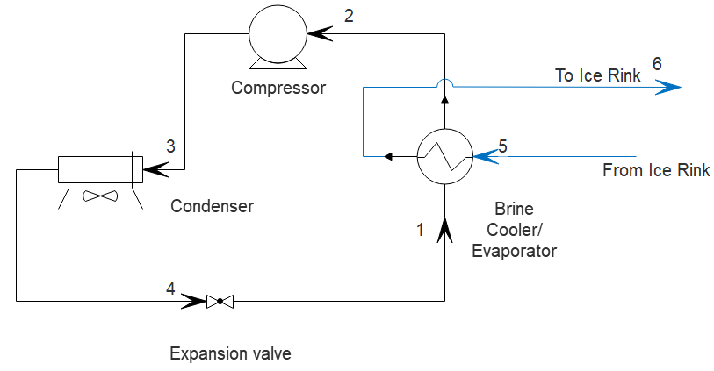

Stream 1 through 4 are all a closed refrigerant loop (currently ammonia) while stream 5 and 6 are brine that is piped under the ice rink. Stream 1 is cold low-pressure liquid ammonia. This liquid enters the evaporator where it absorbs heat from the brine and is converted to a low-temperature vapor (2) this vapor is compressed to a high temperature and high-pressure vapor (3). The fluid next enters the condenser where heat is released to the atmosphere and the fluid condenses (4) into a high-pressure liquid. This liquid enters the expansion valve where the high-pressure liquid is converted into a low temperature liquid (1).

A stream table for the existing ammonia process is given in the table below:

|  |  |  |  |  |  |  |
| --- | --- | --- | --- | --- | --- | --- |
| Stream No. | 1 | 2 | 3 | 4 | 5 | 6 |
| Name | Low T Liq | Low T vap | High T vap | High T Liq | Brine to  Ice Rink | Brine From  Ice Rink |
| Ṁ (kg/min) | unk | unk | unk | unk |  |  |
| T ( °C) | -10 | -10 | 110 | 31 | -5.8 | -3.93 |
| Pres bar | 2.9 | 2.9 | 12 | 12 | 2 | 2 |
| Vapor fraction | 0.0001 | 0.9999 | 1 | 0.0001 | 0 | 0 |

The brine is an aqueous mixture of calcium chloride and has a specific gravity of 1.21 and a heat capacity of 3.37 kJ/(kg K)

a) For the current system, determine the rate that heat is removed (Q̇ in kW) from the brine. This is also known as the duty of the Brine cooler/evaporator

b) Determine the volumetric flow of the brine in L/min

To be safe you would like to match the data for the ammonia sheet as best as you can with the new refrigerant. The crackerjack chemistry crew of Dr. Layson, Benson and Jones have crafted a new formulation for the refrigerant they call “Winter Thunder” and assure you it is completely safe and environmentally friendly. Dr. Moravec has tested the thermodynamic properties and these values are given below:

Cp,liq (kJ/kg K) =

Cp,vap (kJ/kg K) = + T (°C)

ΔHvap (nBP)(kJ/mol) = The heat of vaporization at the normal boiling point

Ρliq (kg/m3) =

MW =

Log10 [Pvap (bar)] = – /[T (K) -]

c) We would like stream 1 to be a saturated liquid – determine the pressure (bar) of this stream.

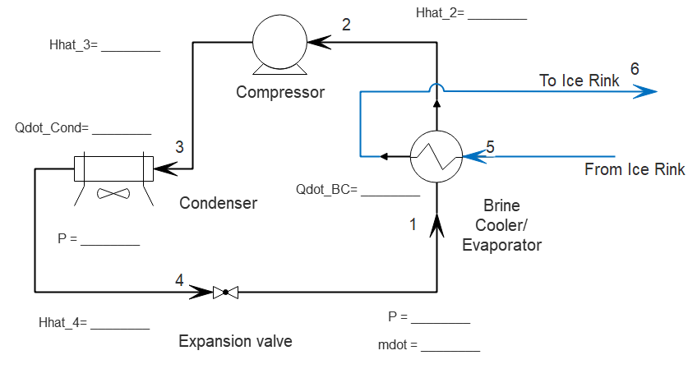

d) Assume both the pressure and temperature of stream 1 and 2 are the same. Take the specific enthalpy of the stream 1 as zero determine the specific enthalpy of stream 2 (kJ/kg)

e) Determine the circulation rate of the refrigerant so that it removes the same amount of heat as the ammonia system in kg/min

f) To determine the temperature of stream 3 we will assume that our refrigerant has the same amount of superheat as the ammonia. How much is stream 3 superheated in the ammonia system (°C)?

g) If temperature of stream 4 is the same as the ammonia system and this is a saturated liquid, what is the pressure of stream 3 and 4 for our system (bar)?

h) What is the duty of the condenser for the new system (kW) - that is what is the rate of heat removal from the refrigerant?

**Answer 3 of the following questions. Your response should be type written:**

I) If a brass or carbon steel valve was used in the ammonia system would they have failed? What are some acceptable materials for a valve in ammonia service. Please reference your work.

II) In addition to Winter Thunder, what are at least two alternatives to ammonia in Ice Rink refrigeration systems. Again, cite your references

III) Look up at least two references on Ice rink construction. Give two facts that you did not know. Why is the ground under the ice rink heated? Is there any place within the refrigeration system that this heat could be obtained?

IV) Is the heat duty for the problem realistic for ice rinks in this area? How do you know? Give a reference and if the values are not realistic, what are more realistic values.

V) Could the T1 (the temperature of stream 1) be picked so that it is 0°C? Why or why not? Could T4 be chosen to be 15°C? why or why not? Would are two reasons why not to have T4 = 90°C?

VI) Suppose the circulating rate of the brine is adjusted to keep up with the heat load in the ice rink, list three conditions or activities in the ice rink would cause the circulating rate of the brine to increase.

VII) Compare the duties of the two exchangers in the refrigeration system. Which is larger and by what percentage? Why are they not the same?

VIII) In addition to the assumptions made in the problem statement, what additional assumptions did you have to make to solve this problem? How reasonable do you think these assumptions are?

IX) Find a diagram of a home air conditioner system on Wikipedia (or similar). What are some similarities and differences between the refrigeration system in a house air conditioner and the one shown above.

X) Look up the history of Ice skating or Ice Hockey. Where and when did it start? When did it become an Olympic sport.? Make sure to cite your references. What were the first rinks cooled with? Have there been any accidents involving the refrigeration system? When and where?

Base-Case (Index # =1)



Cp,liq (kJ/kg K) = 4.5

Cp,vap (kJ/kg K) = 2.04+ 0.00187 T (°C)

ΔHvap (nBP)(kJ/mol) = 23.5 The heat of vaporization at the normal boiling point

Ρliq (kg/m3) = 640

MW = 17

Log10 [Pvap (bar)] = 3.19 – 506.7/[T (K) -80.8]